Name: Kashif Raza
Course: Python With Ai
Teacher Name: Miss Qirrat
Practice Question 2:
Code:

s = input("enter a string: ")
length = len(s)

if length > 5:
mid = length // 2
fhalf = s[:mid]
shalf = s[mid:]

if fhalf == shalf[::-1]:
print("Palindrome Half")
elif s.isupper():
vowels = "AEIOU"
result = ""
for ch in s:
if ch not in vowels:
result += ch
print(result)
else:
swapped = shalf + fhalf
print(swapped)
else:
modified = s[1:]
print(modified + modified)

Output:
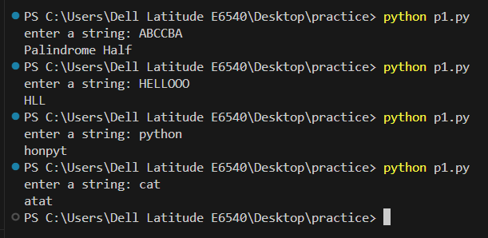

Practice Question 2:
Code:
a s = input("enter a string: ")
length = len(s)

if 6<length<12:
if s[0] == s[-1]:
print(s[1:-1])
elif " " in s:
print(s.split()[0])
else:
print(s[::2])
else:
print(s[::-1])

OUTPUT
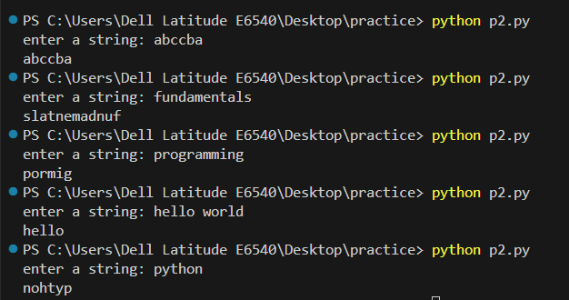

Practice Question 3:
Code:
s = input("enter a string: ")

fchar = s[0].lower()
lchar = s[-1]
length = len(s)
mid = length // 2

vowels = "aeiou"

if fchar.isalpha() and fchar not in vowels:
if lchar.isdigit():
# reverse sirf first half ko
fhalf = s[:mid][::-1]
shalf = s[mid:]
print(fhalf + shalf)
else:
# reverse sirf second half ko
fhalf = s[:mid]
shalf = s[mid:][::-1]
print(fhalf + shalf)
else:
print(s.replace(" ", ""))

OUTPUT:
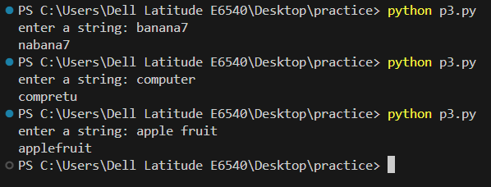

Practice Question 4:
Code:
s = input("Enter a string: ")
length = len(s)

if length > 8:
mid = length // 2
first_half = s[:mid]
second_half = s[mid:]
if first_half == second_half:
print("Mirror String")
elif s[0].lower() in "aeiou":
print(s[1:-1])
else:
print(s[::-1])
else:
print(s.upper())

OUTPUT:
